Name:______________________ Class:________
WEEK 8
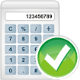
- Which has the same value as 9⁴?
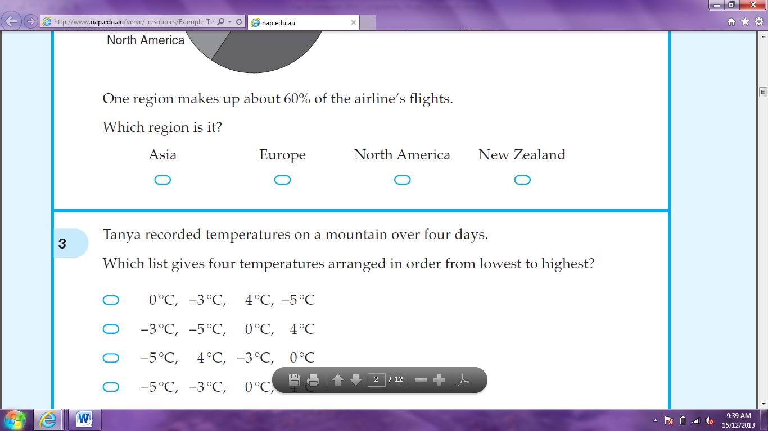



4⁹ 6³ 3⁶ 3⁸

- What is the value of ?

- A car uses petrol at a rate of 8 litres for every 100 km travelled. How far will the car travel on a full tank of 60 litres?

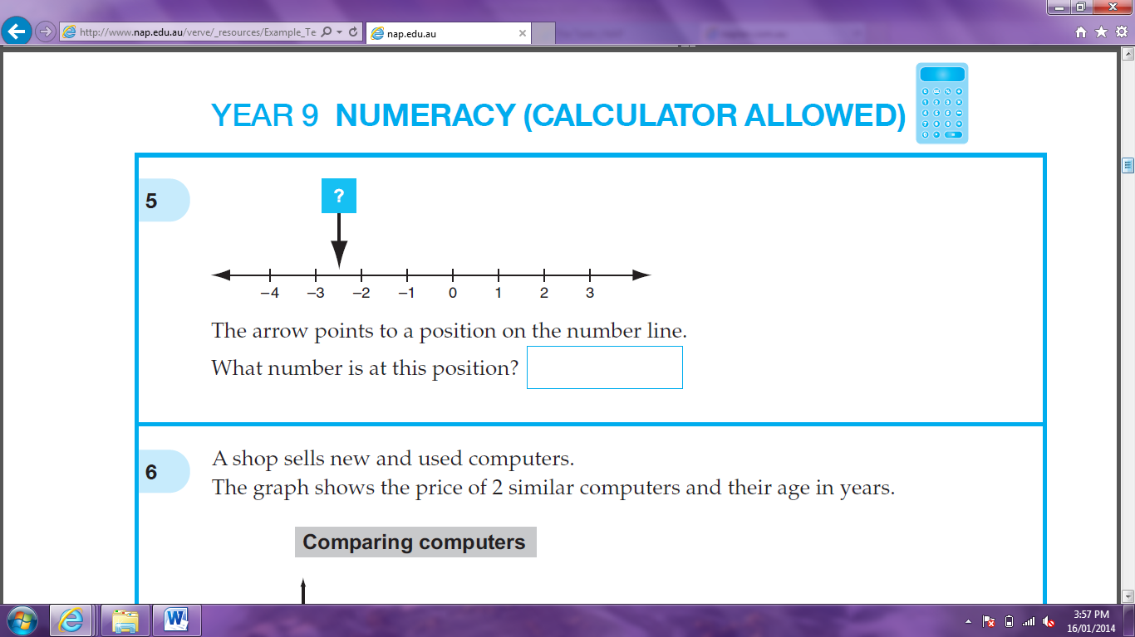
- The arrow points to a position on the number line. What number is at this position.

- Peter wants to paint his bedroom walls. What information will best help him decide how much paint to buy?




volume of room capacity of room perimeter of all walls area of all walls
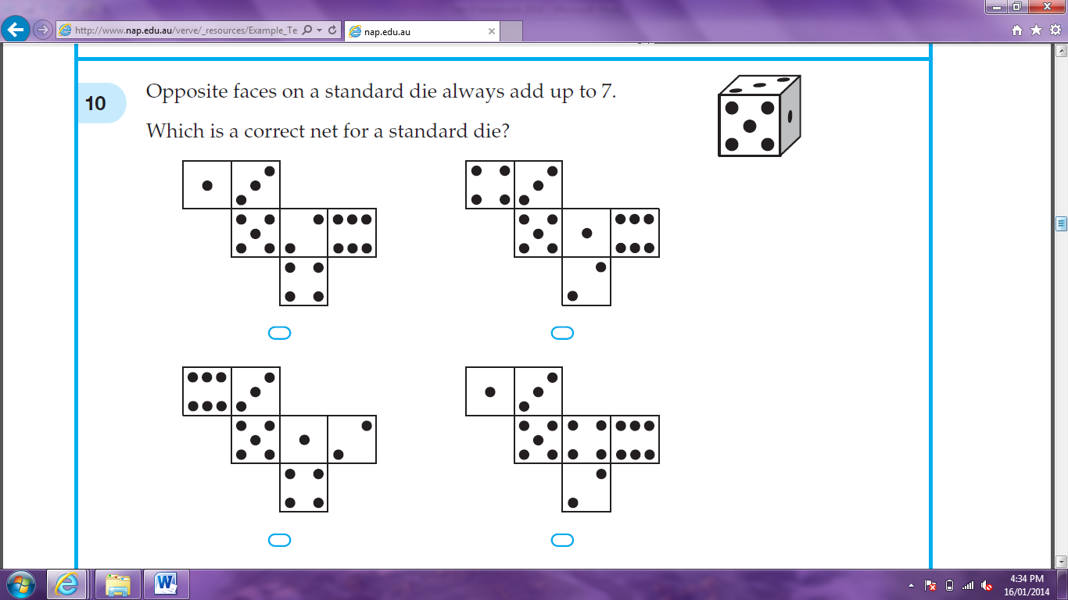


- Opposite faces on a standard die always add up to 7. Which is a correct net for a standard die?

- A water tank has a capacity of 6.25 kilolitres. How many litres does the tank hold when it is full?

- The value of y is given by the rule y = 4 – x². What is the value of y when x = 1.5?

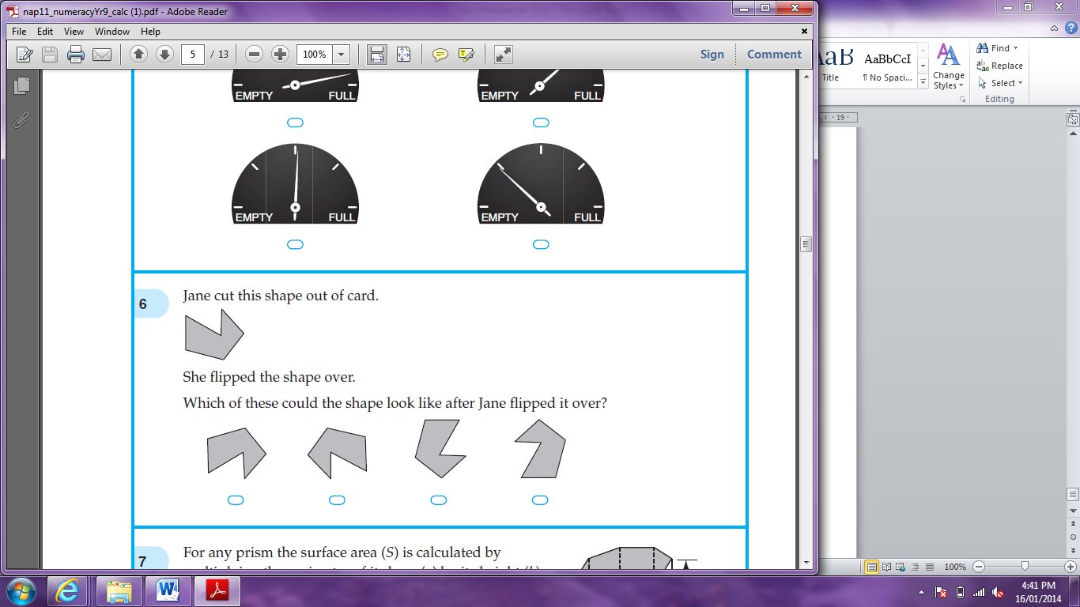
- Jane cut this shape out of card. She flipped the shape over. Which of these could the shape look

like after Jane flipped it over?

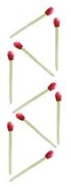

- Matches are used to make this pattern of triangles. In this pattern the rule for the number of matches is:

2 x number of triangles

3 x number of triangles
2 x number of triangles + 1

3 x number of triangles – 1

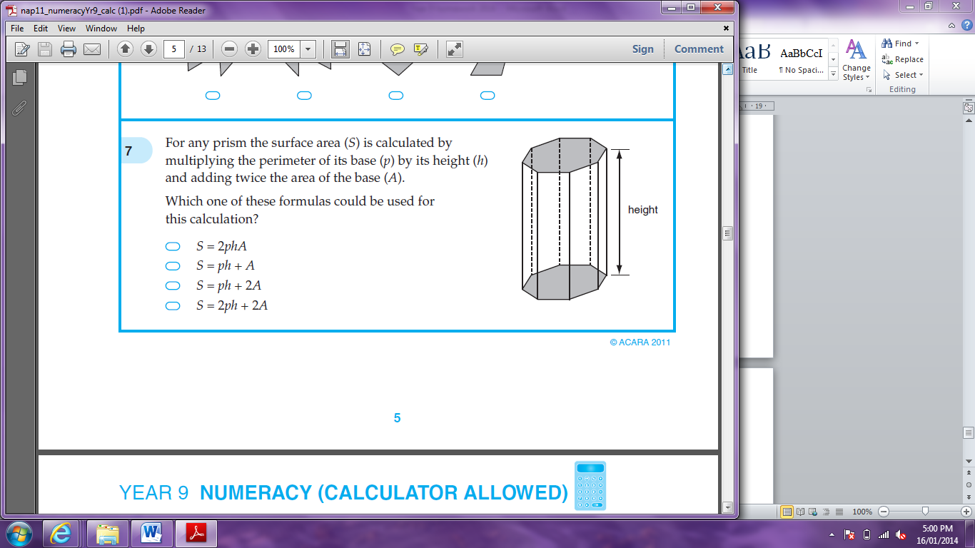
- For any prism the surface area (S) is calculated by multiplying the perimeter of its base (p) by its height (h) and adding twice the area of the base (A). Which of these formulas could be used for this calculation?

S = 2phA

S = ph + A

S = ph + 2A
S = 2ph + 2A

- There are 200 animals on a farm. One-fifth of the animals are sheep and the rest are cattle. 40% of the cattle are calves. How many calves are on the farm?

- Which number is prime?




111 113 117 119

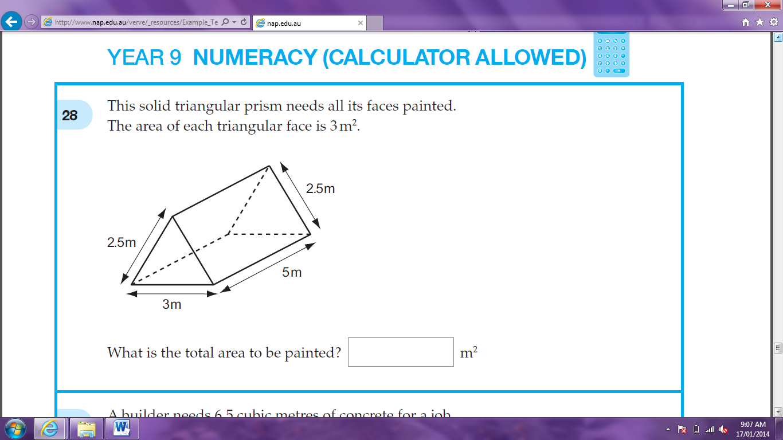
- This solid triangular prism needs all its faces painted. The area of each triangular face is 3m². What is the total area to be painted?

- Amanda sells T-shirts at a market for $15 each. Her costs are $6 per T-shirt and $540 per month rent. How many T-shirts must Amanda sell per month to equal her monthly costs?

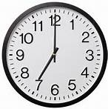
- The clock shows that it is seven o’clock. What is the size of the obtuse angle formed by the hands?

- The mean (average) of eight numbers is 56. When one of the numbers was left out, the mean decreased to 54. What number was left out?




54 56 60 70

